**CSE Assignment – 4**

**Name : Prashant Dhimal**

**Registration number : AP22110011492**

**Section : ‘W’**

1. 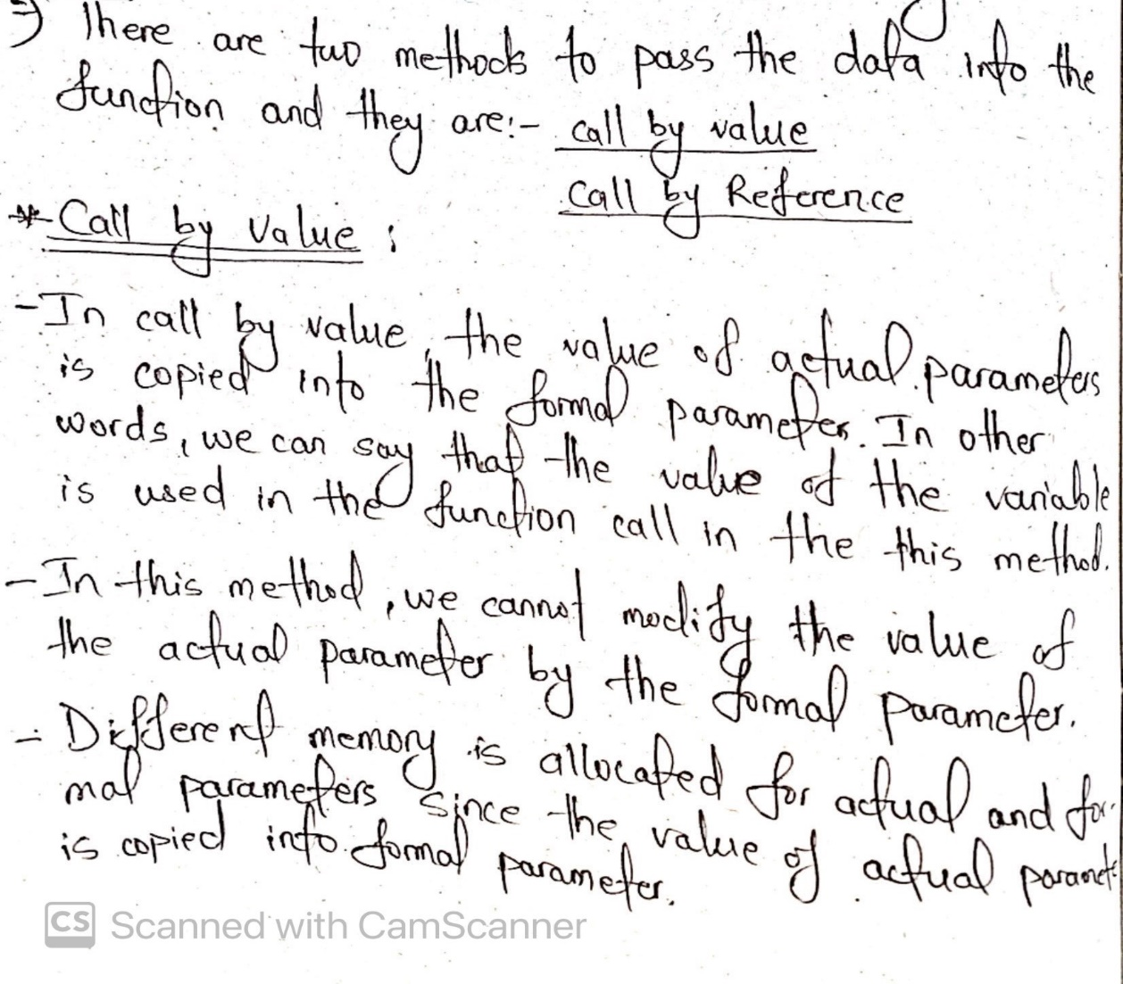**Explain about call by value and call by reference with suitable examples.**

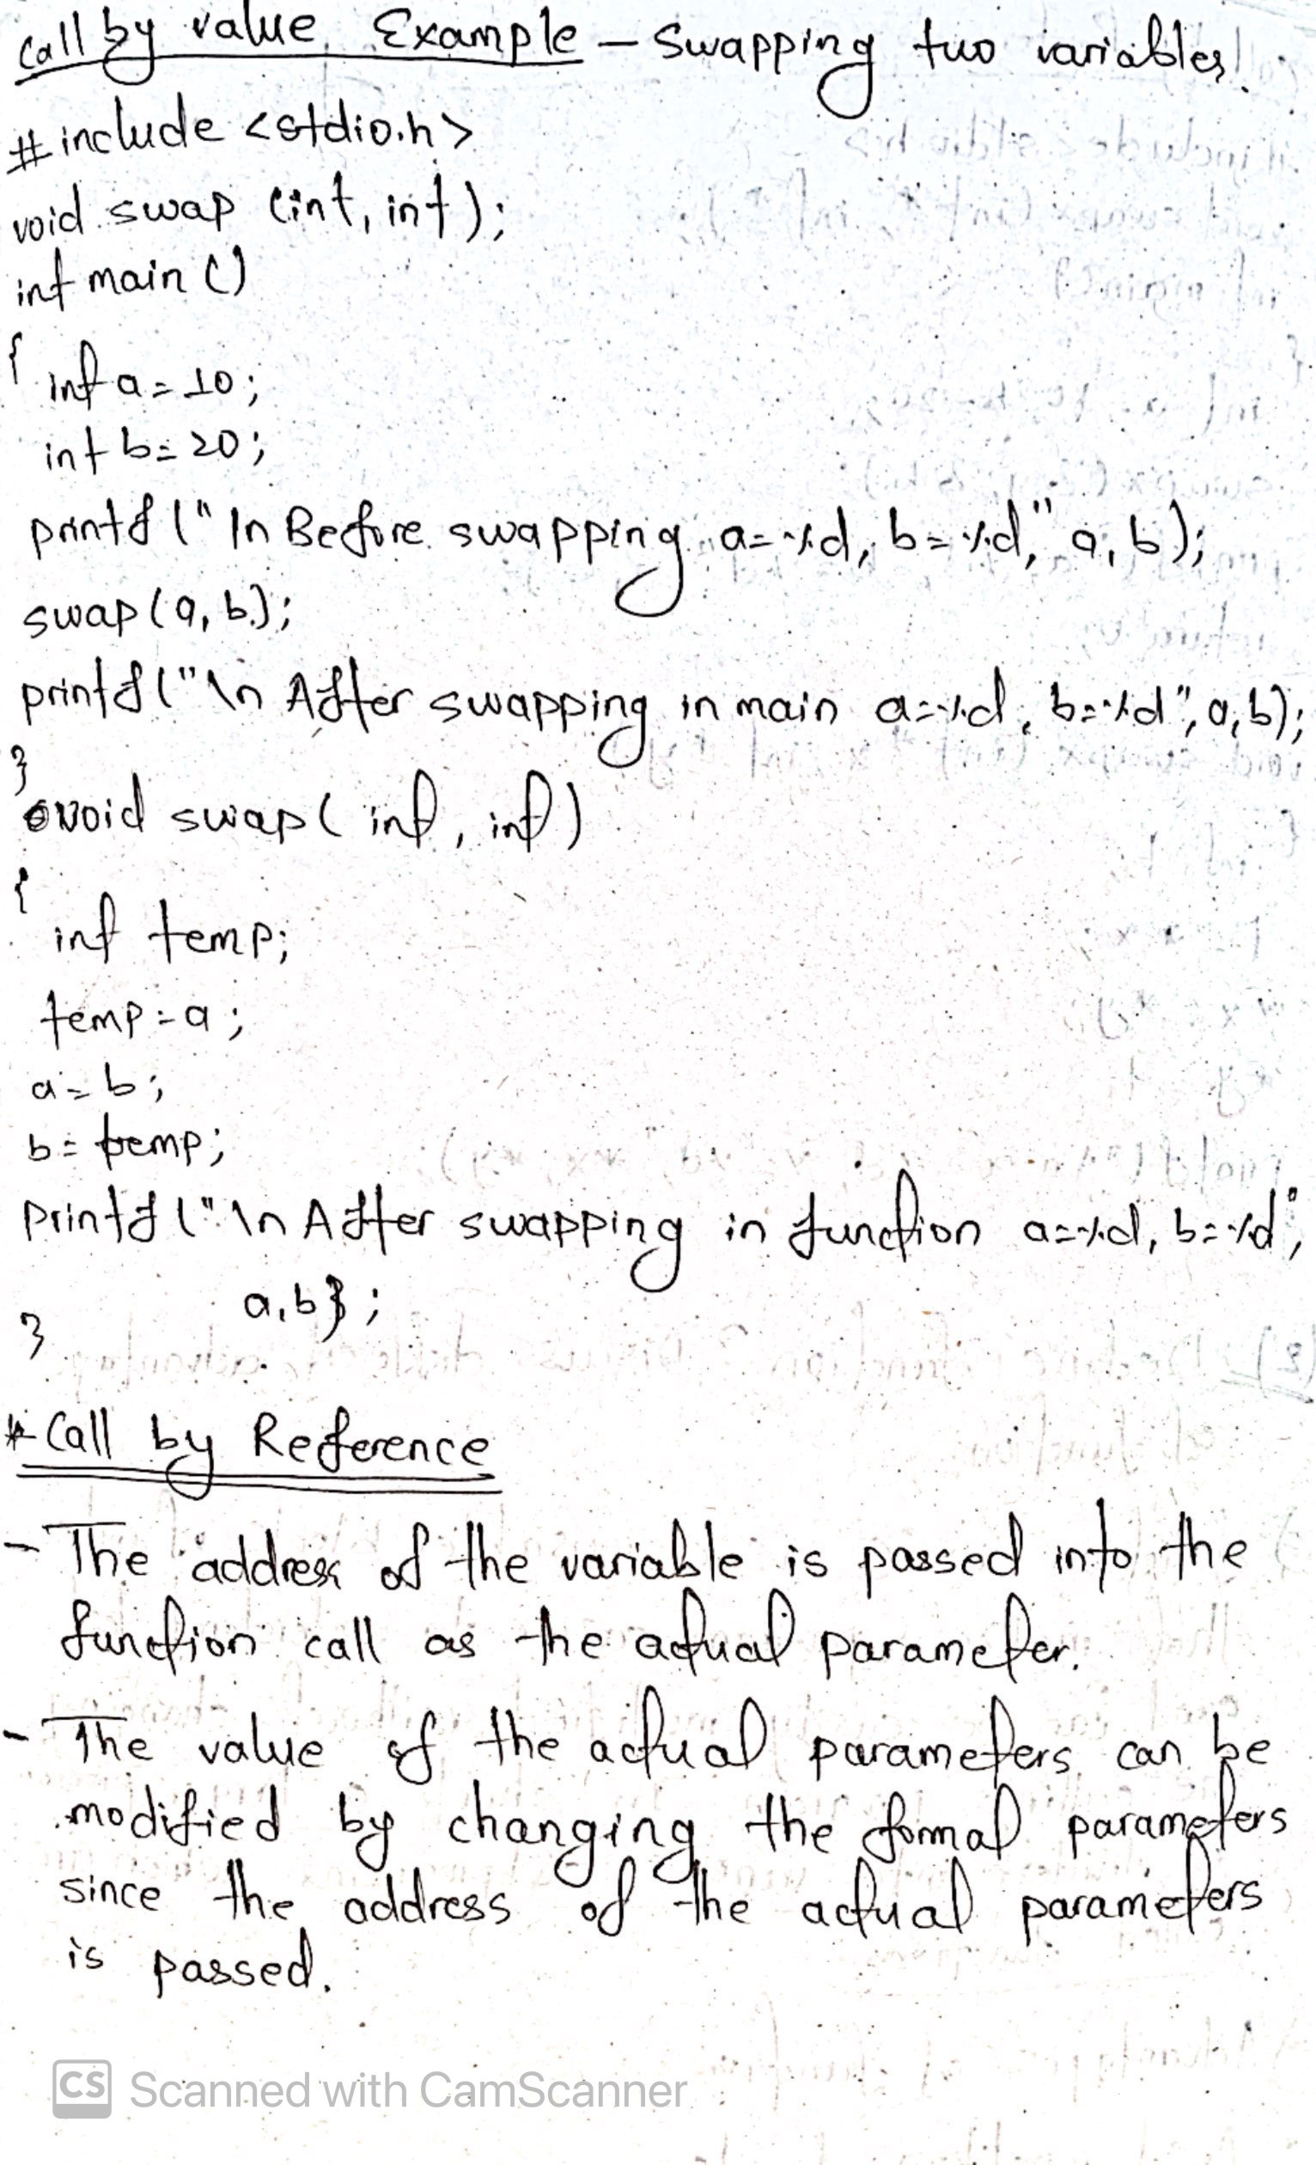

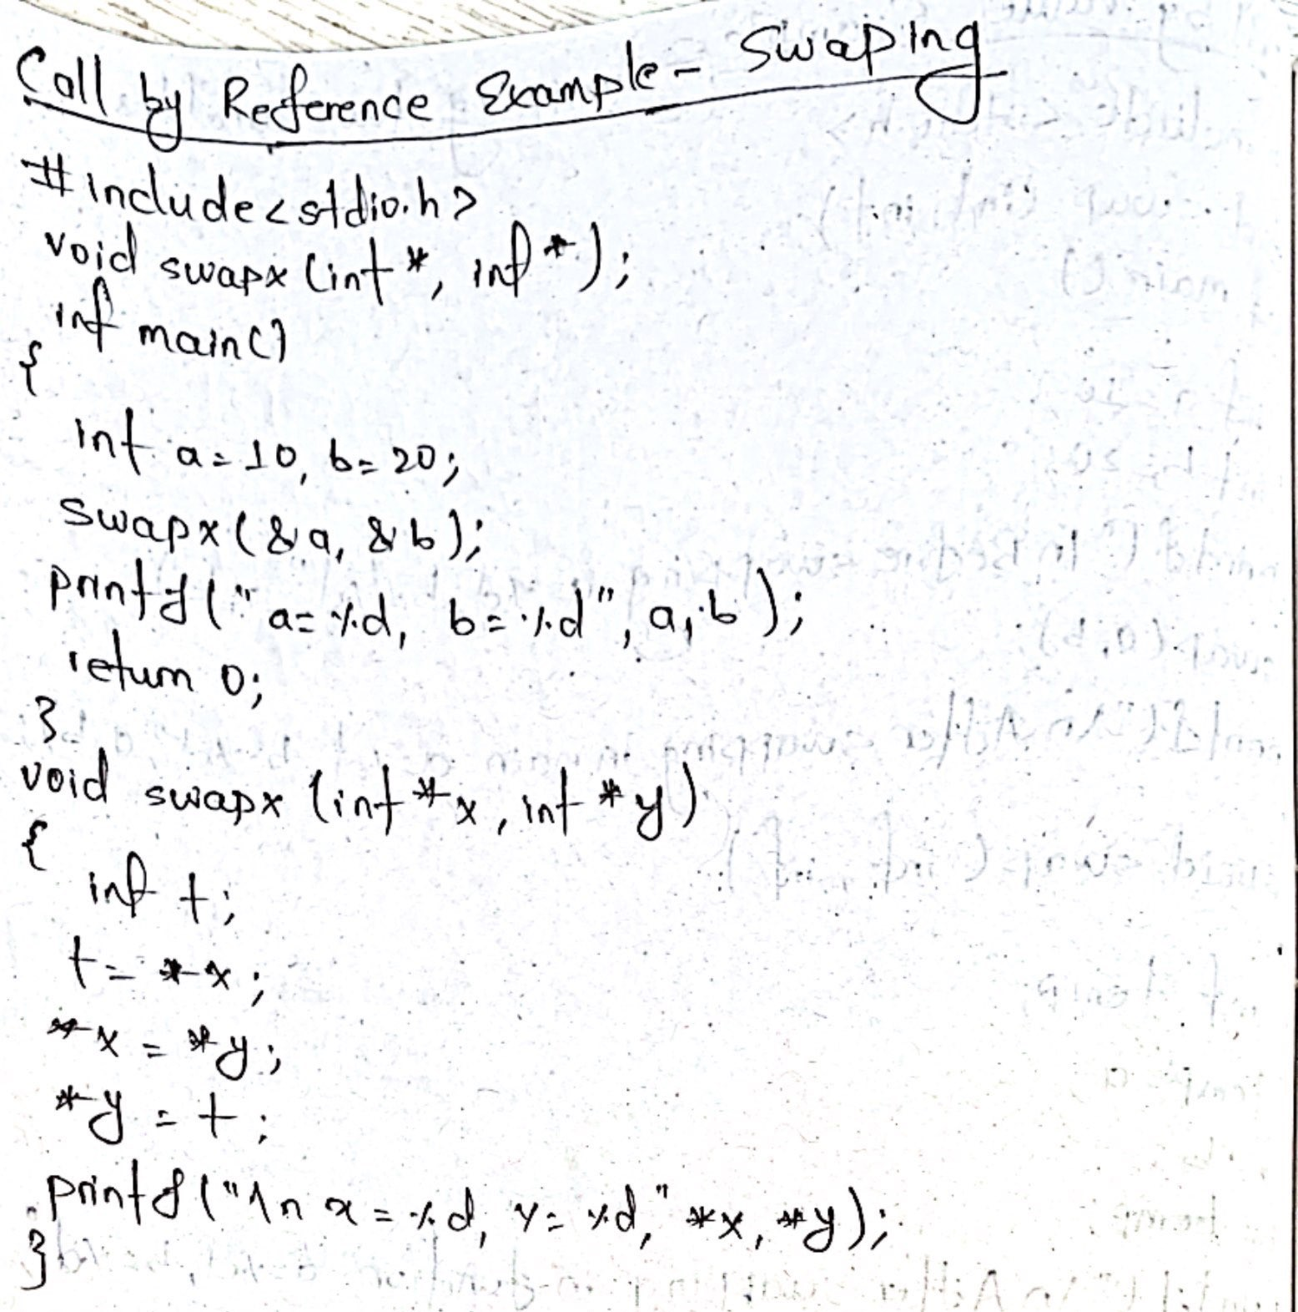

1. 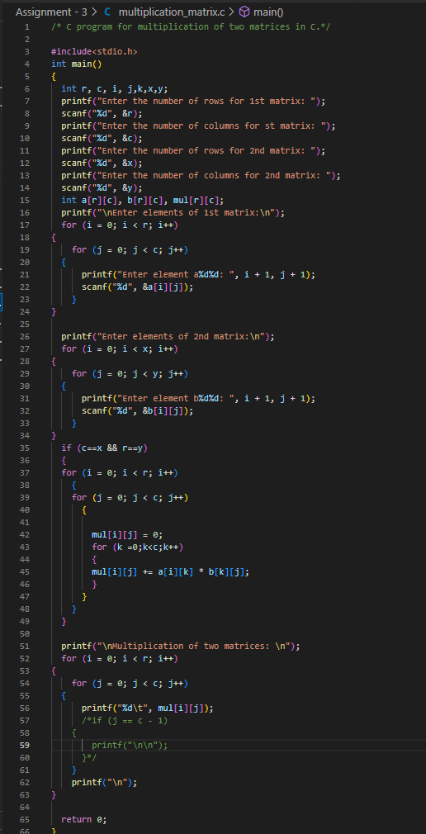**Write a C program for Multiplication of two matrixes.**
2. **Write a C program to implement Fibonacci series using recursion.**

* 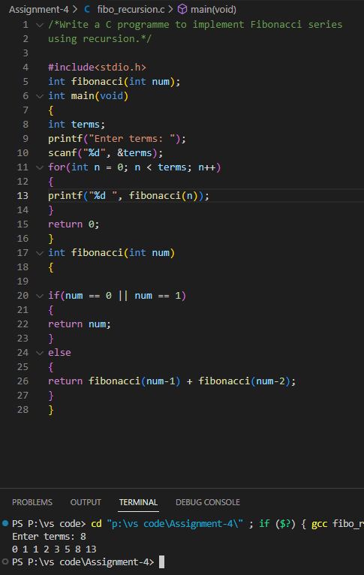

1. 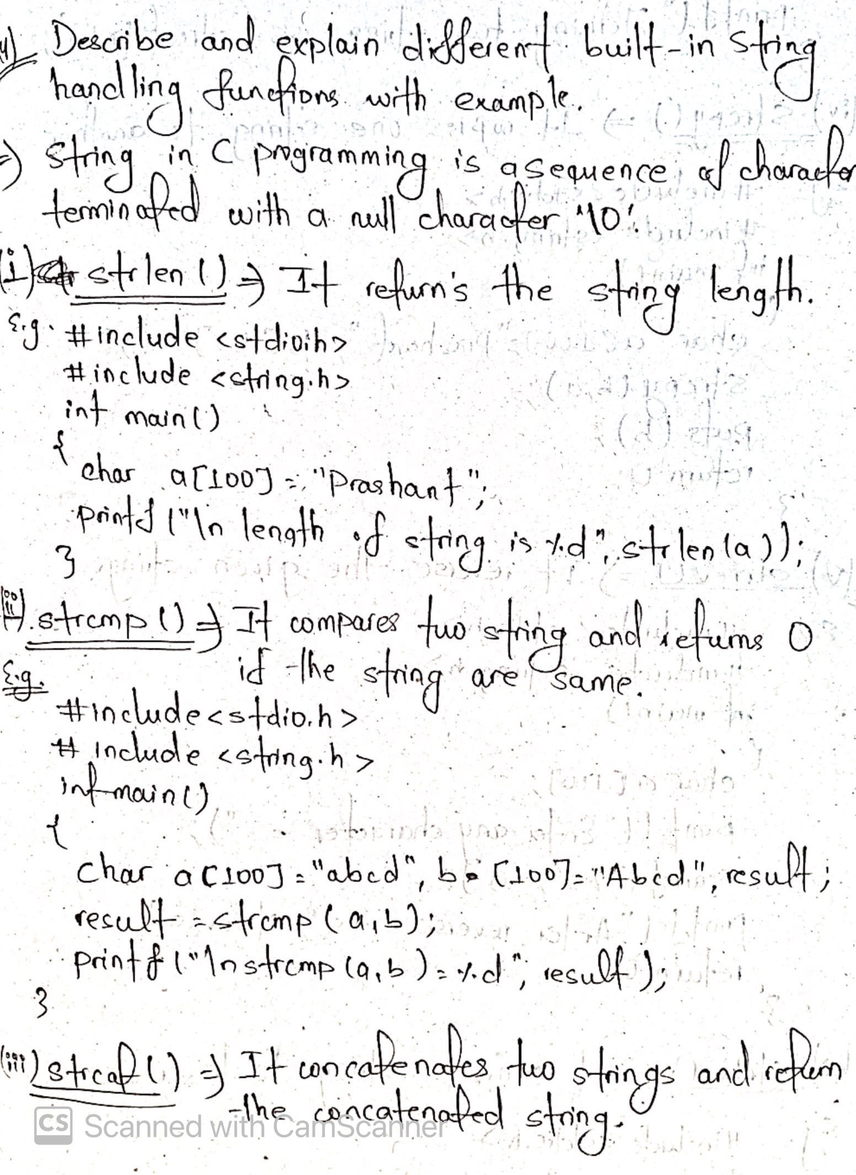**Explain about String handling functions?**

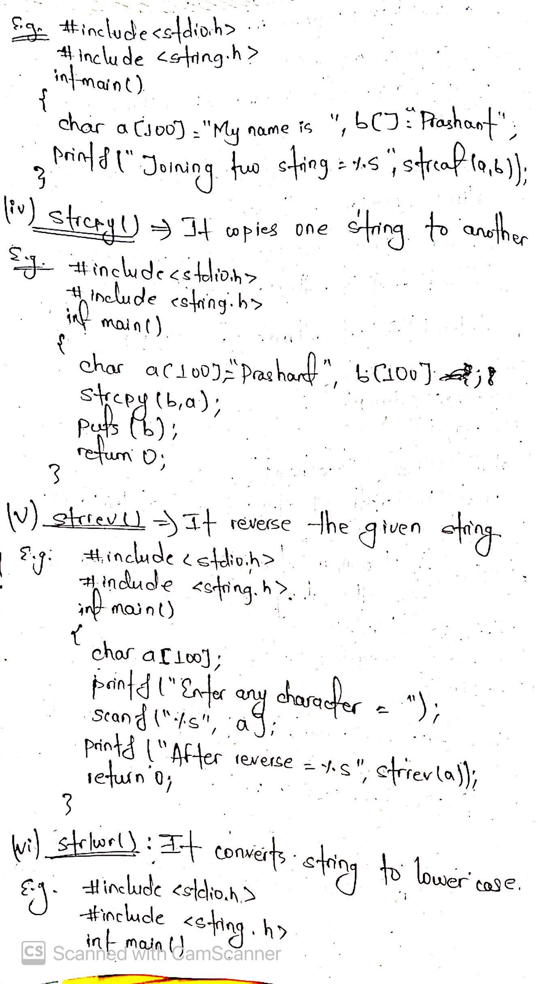

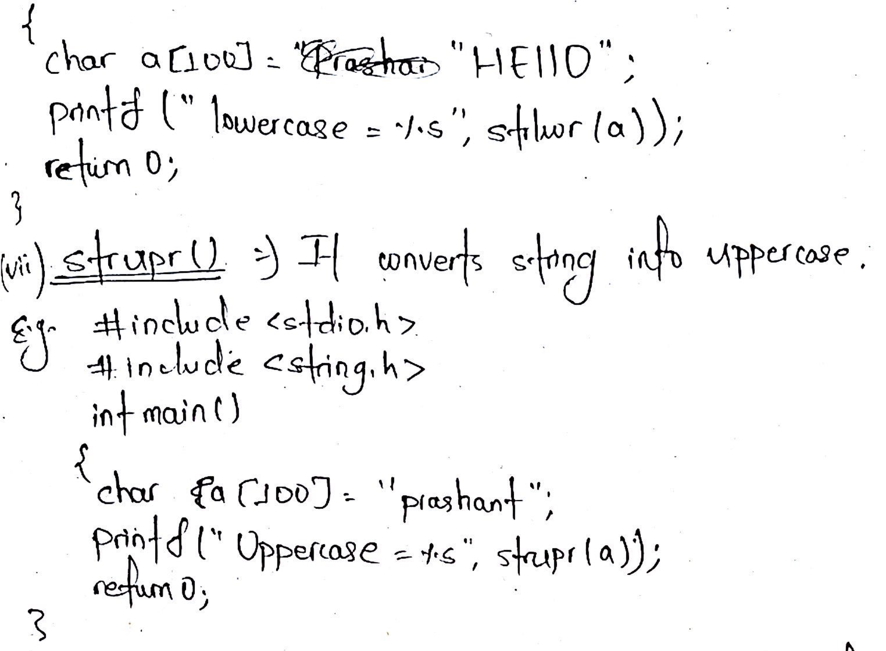

1. 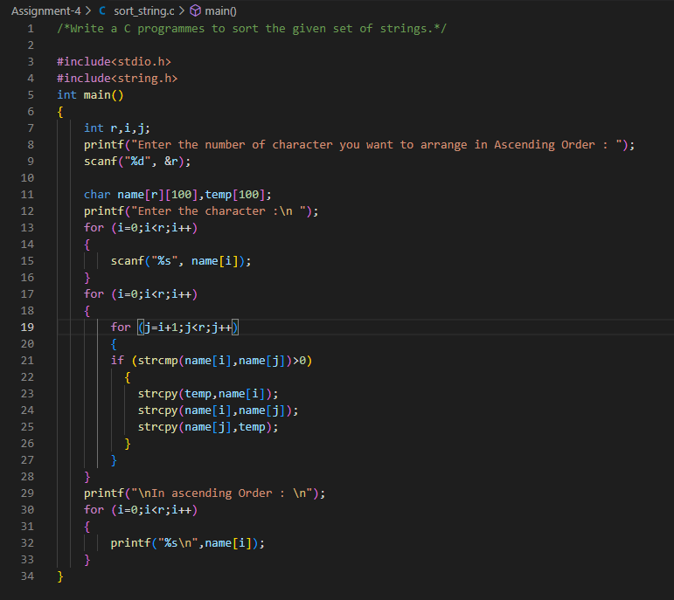**Write a C program to sort the given set of strings.**
2. 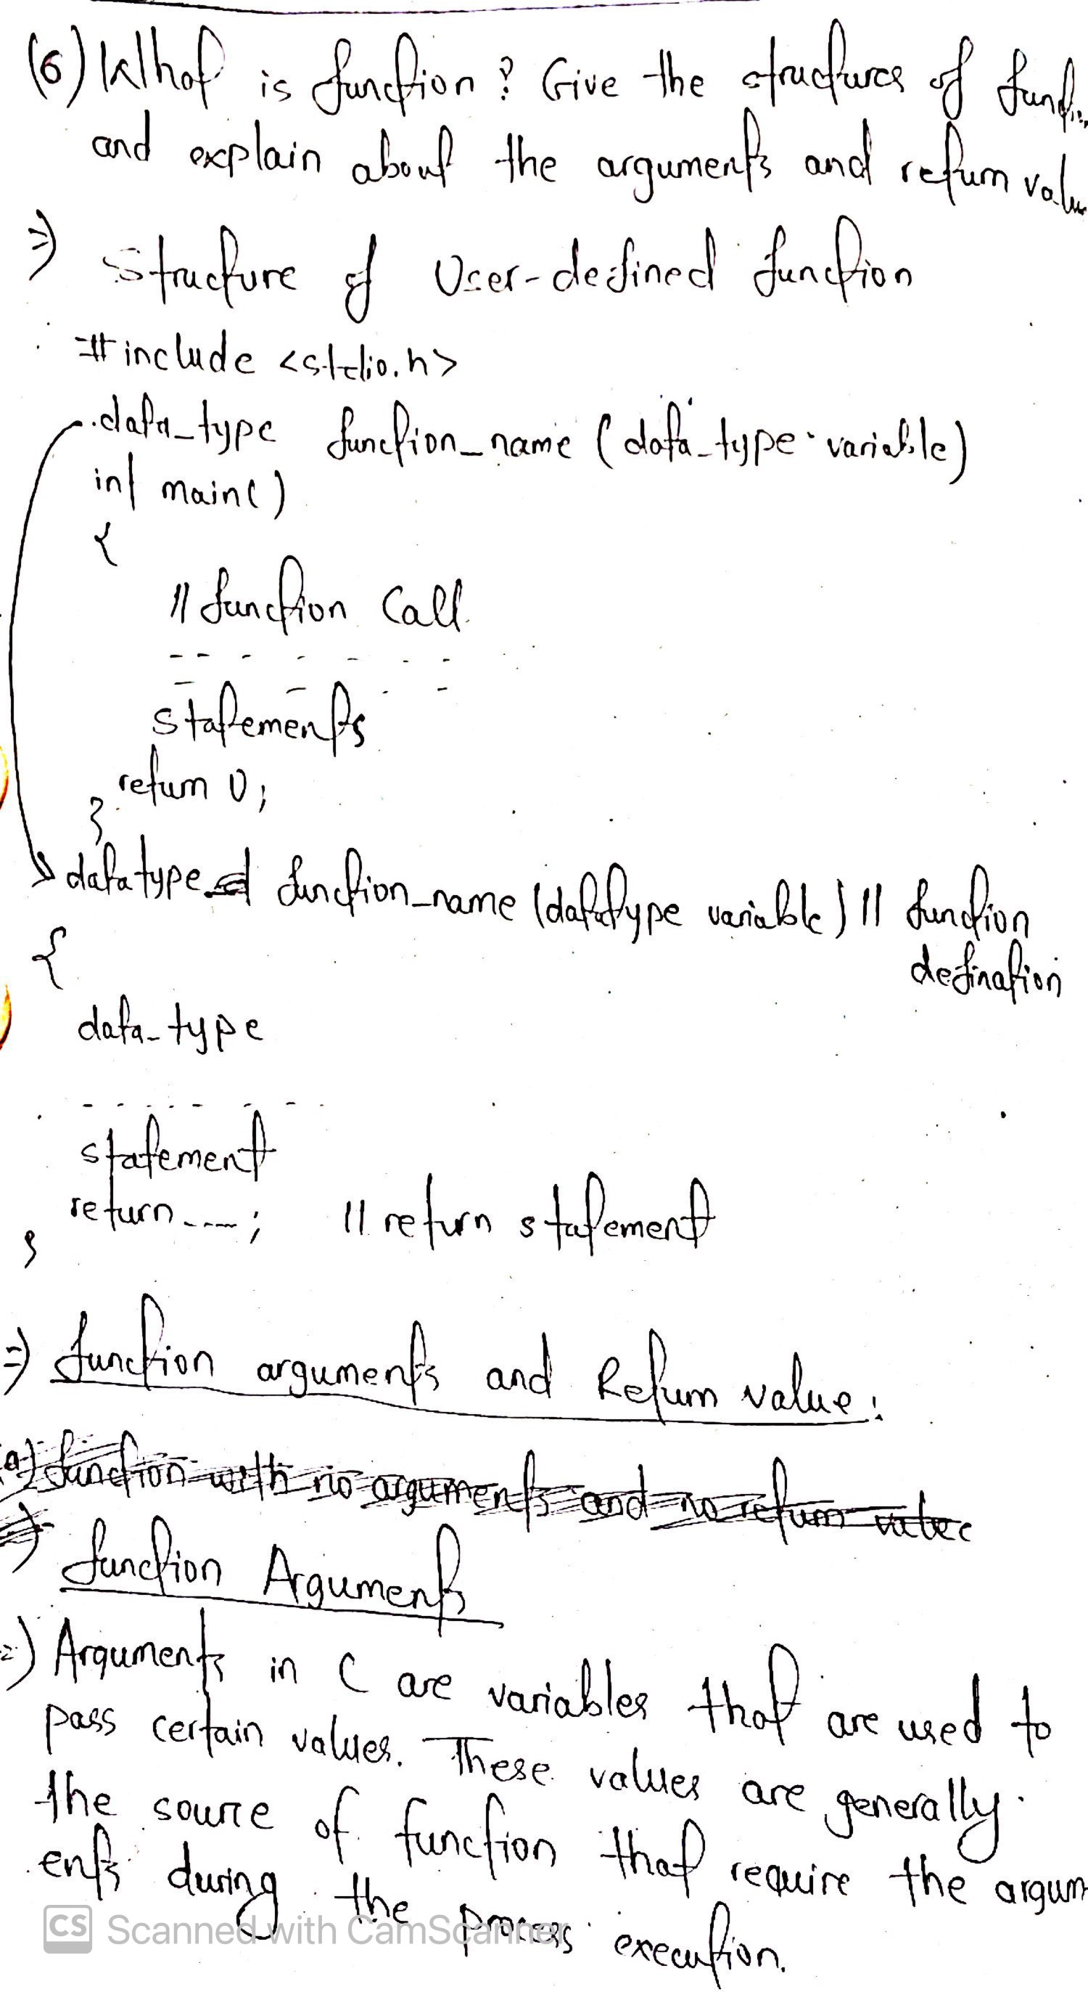**What do u mean by a function? Give the structure of user defined function and explain about the arguments and return values.**
3. **Write a program to read, calculate average and print student marks using array of structures.**

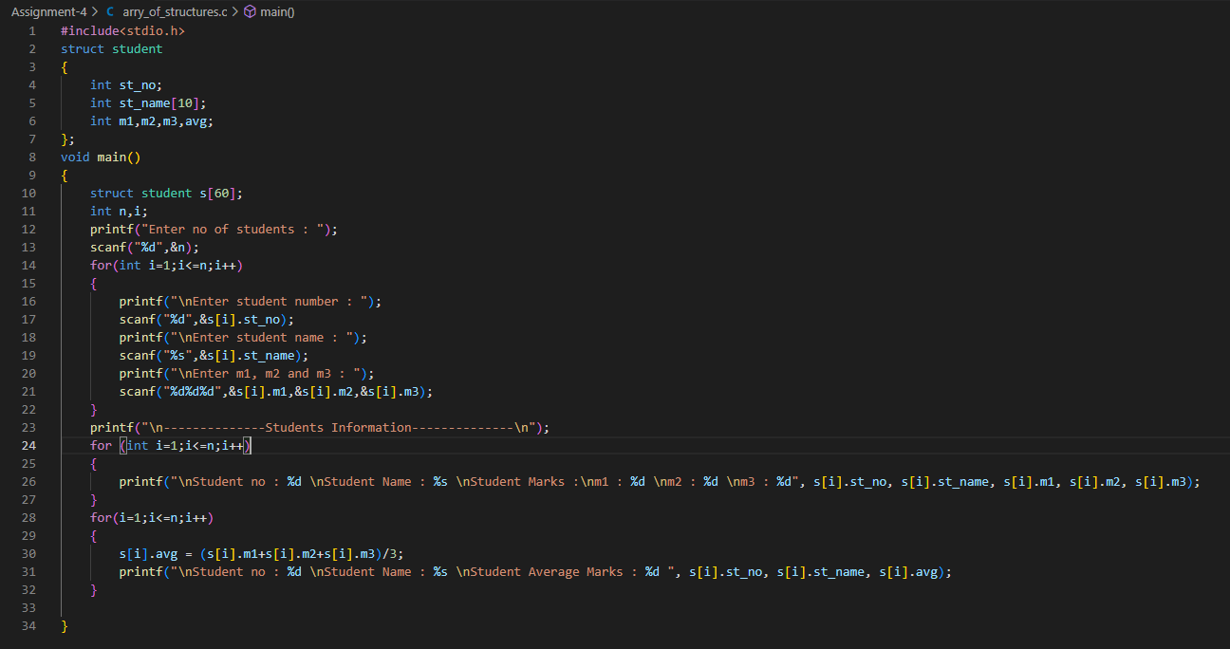

1. **Differentiate between self-referential structure and nested structure with example.**

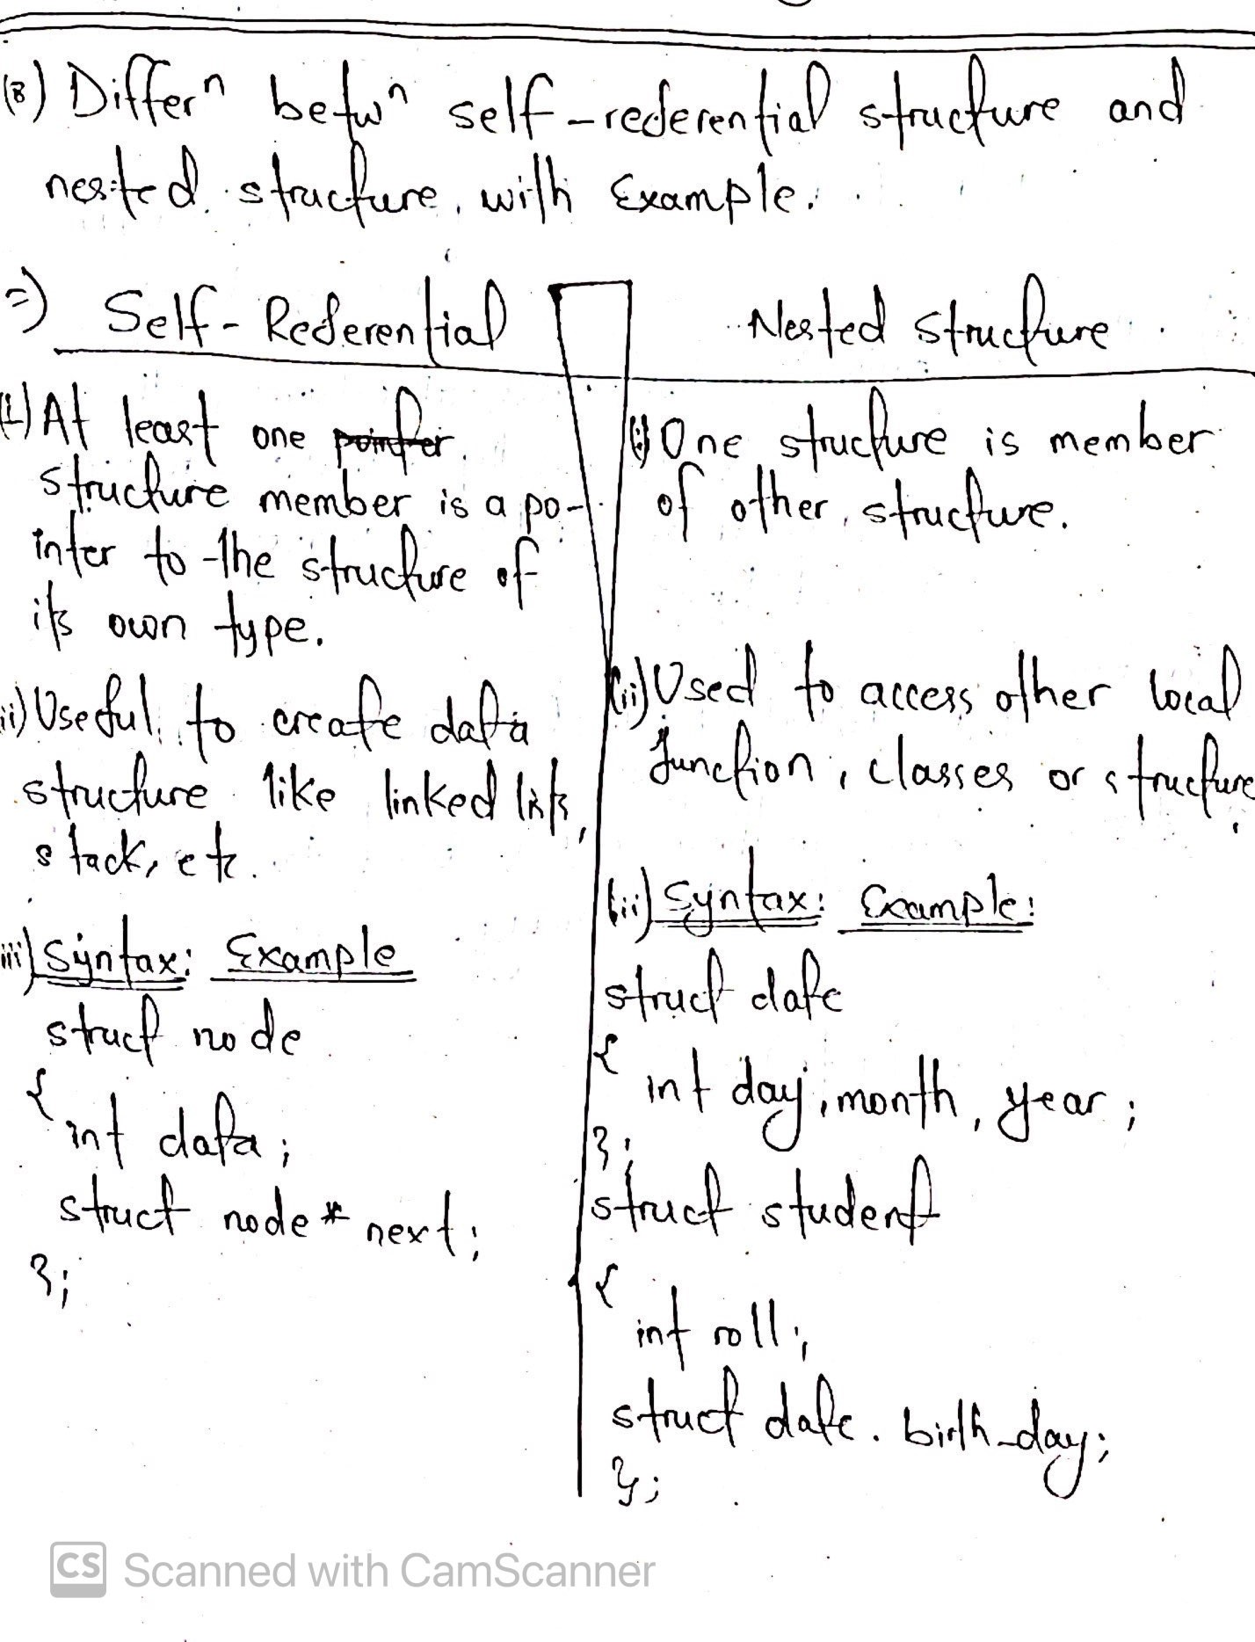

1. **Explain three dynamic memory allocation functions with suitable**
2. 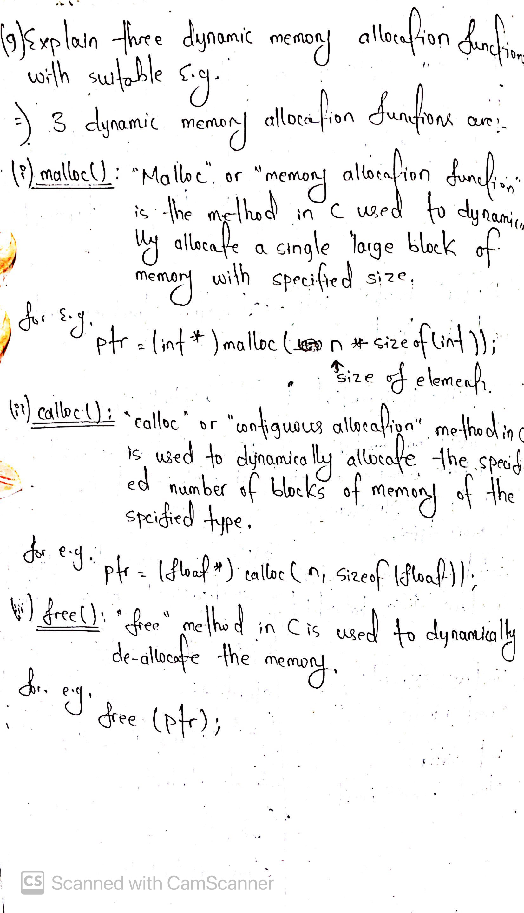**Explain about storage classes**.

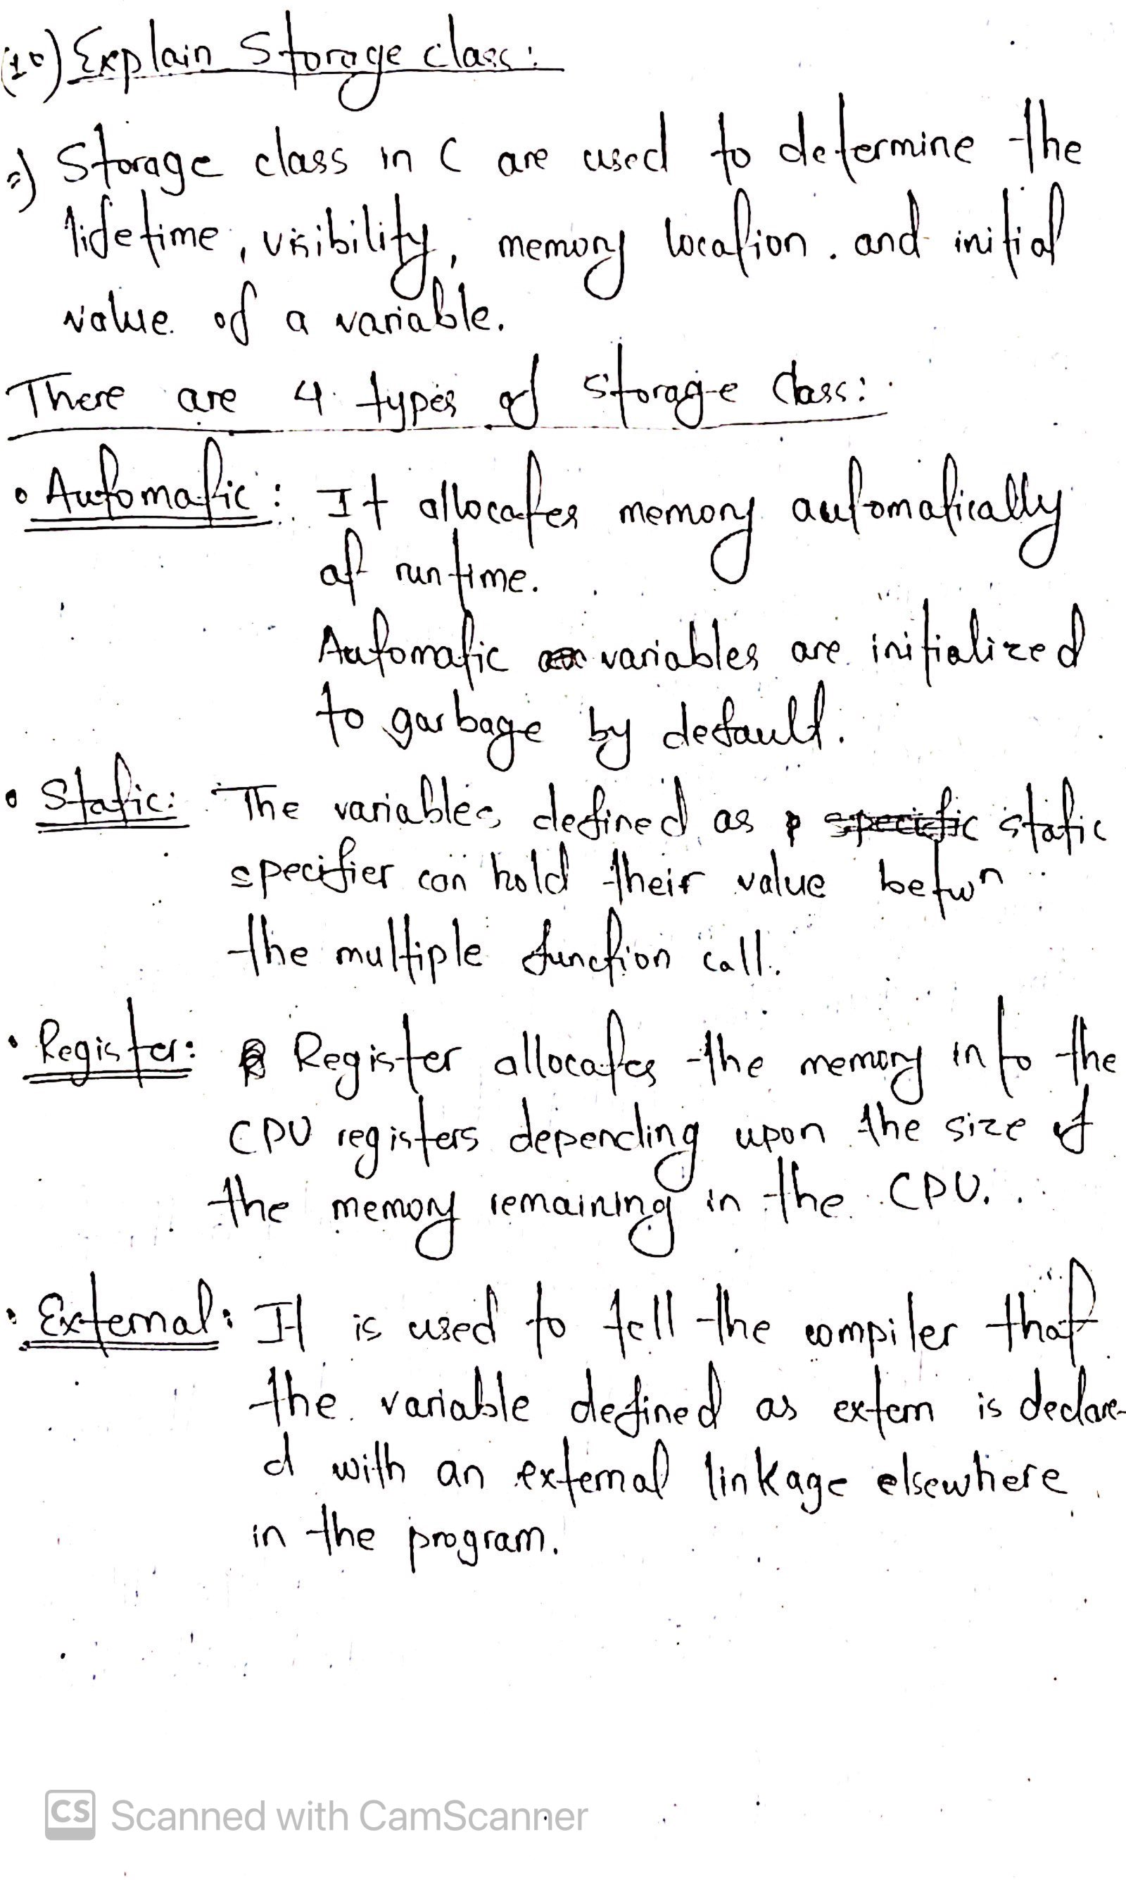

1. 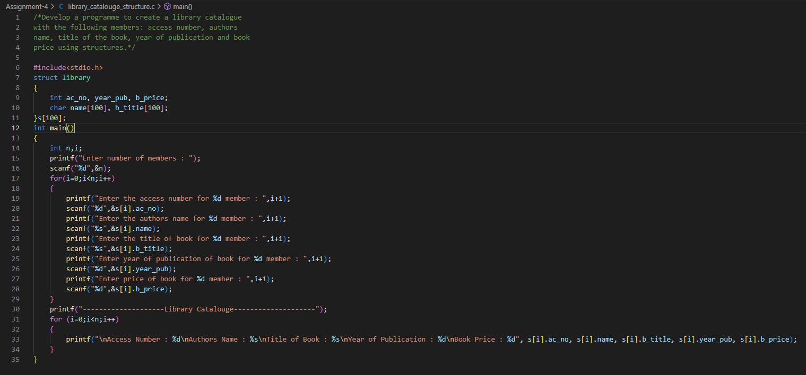**Develop a program to create a library catalogue with the following members: access number, authors name, title of the book, year of publication and book price using structures.**
2. **Explain about command line arguments with an example.**

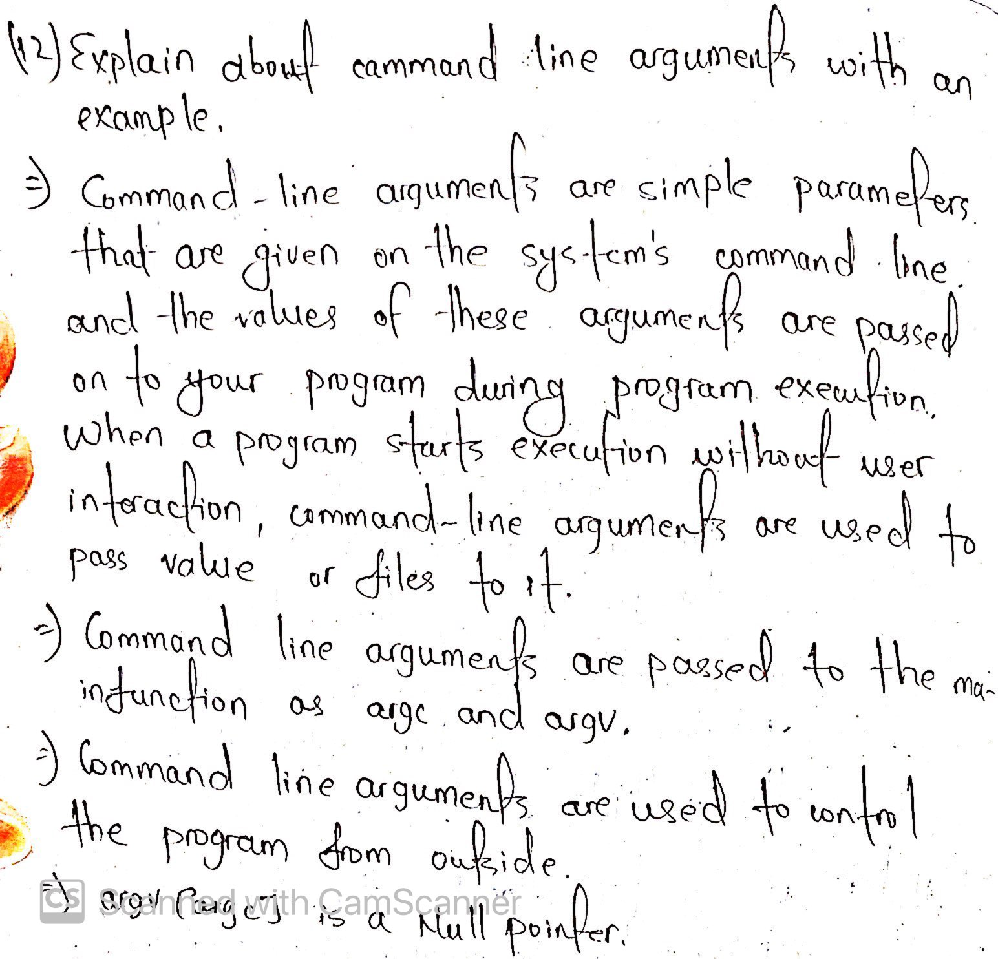

1. 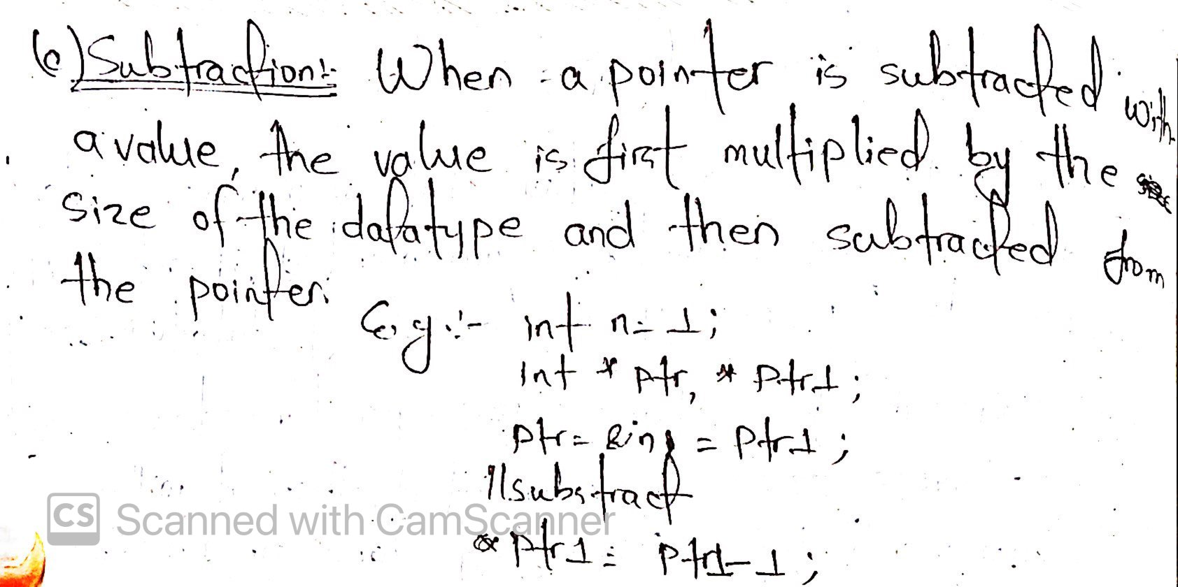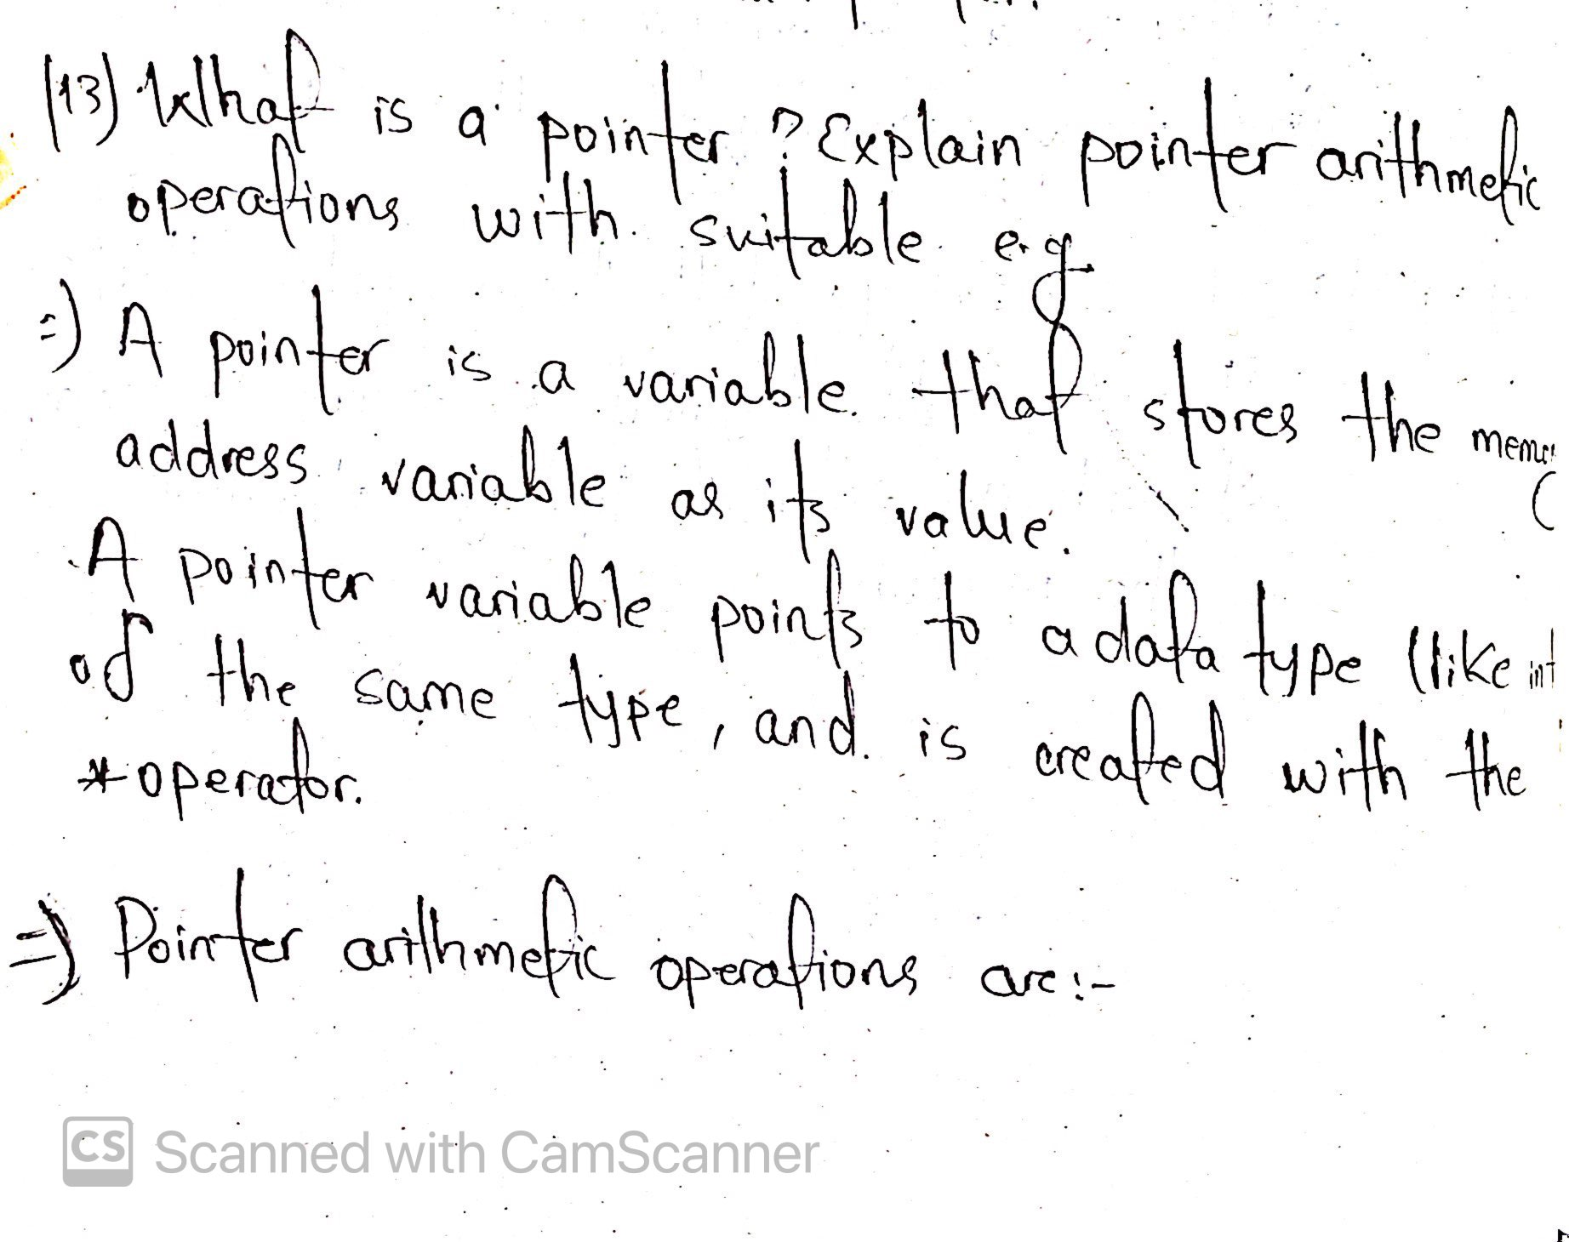**What is a Pointer? Explain pointer arithmetic operations with suitable examples.**

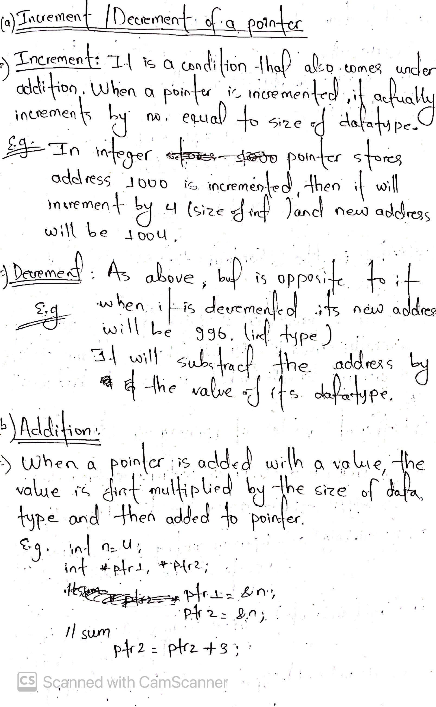

1. **What is a file? Explain different modes of opening a file.**

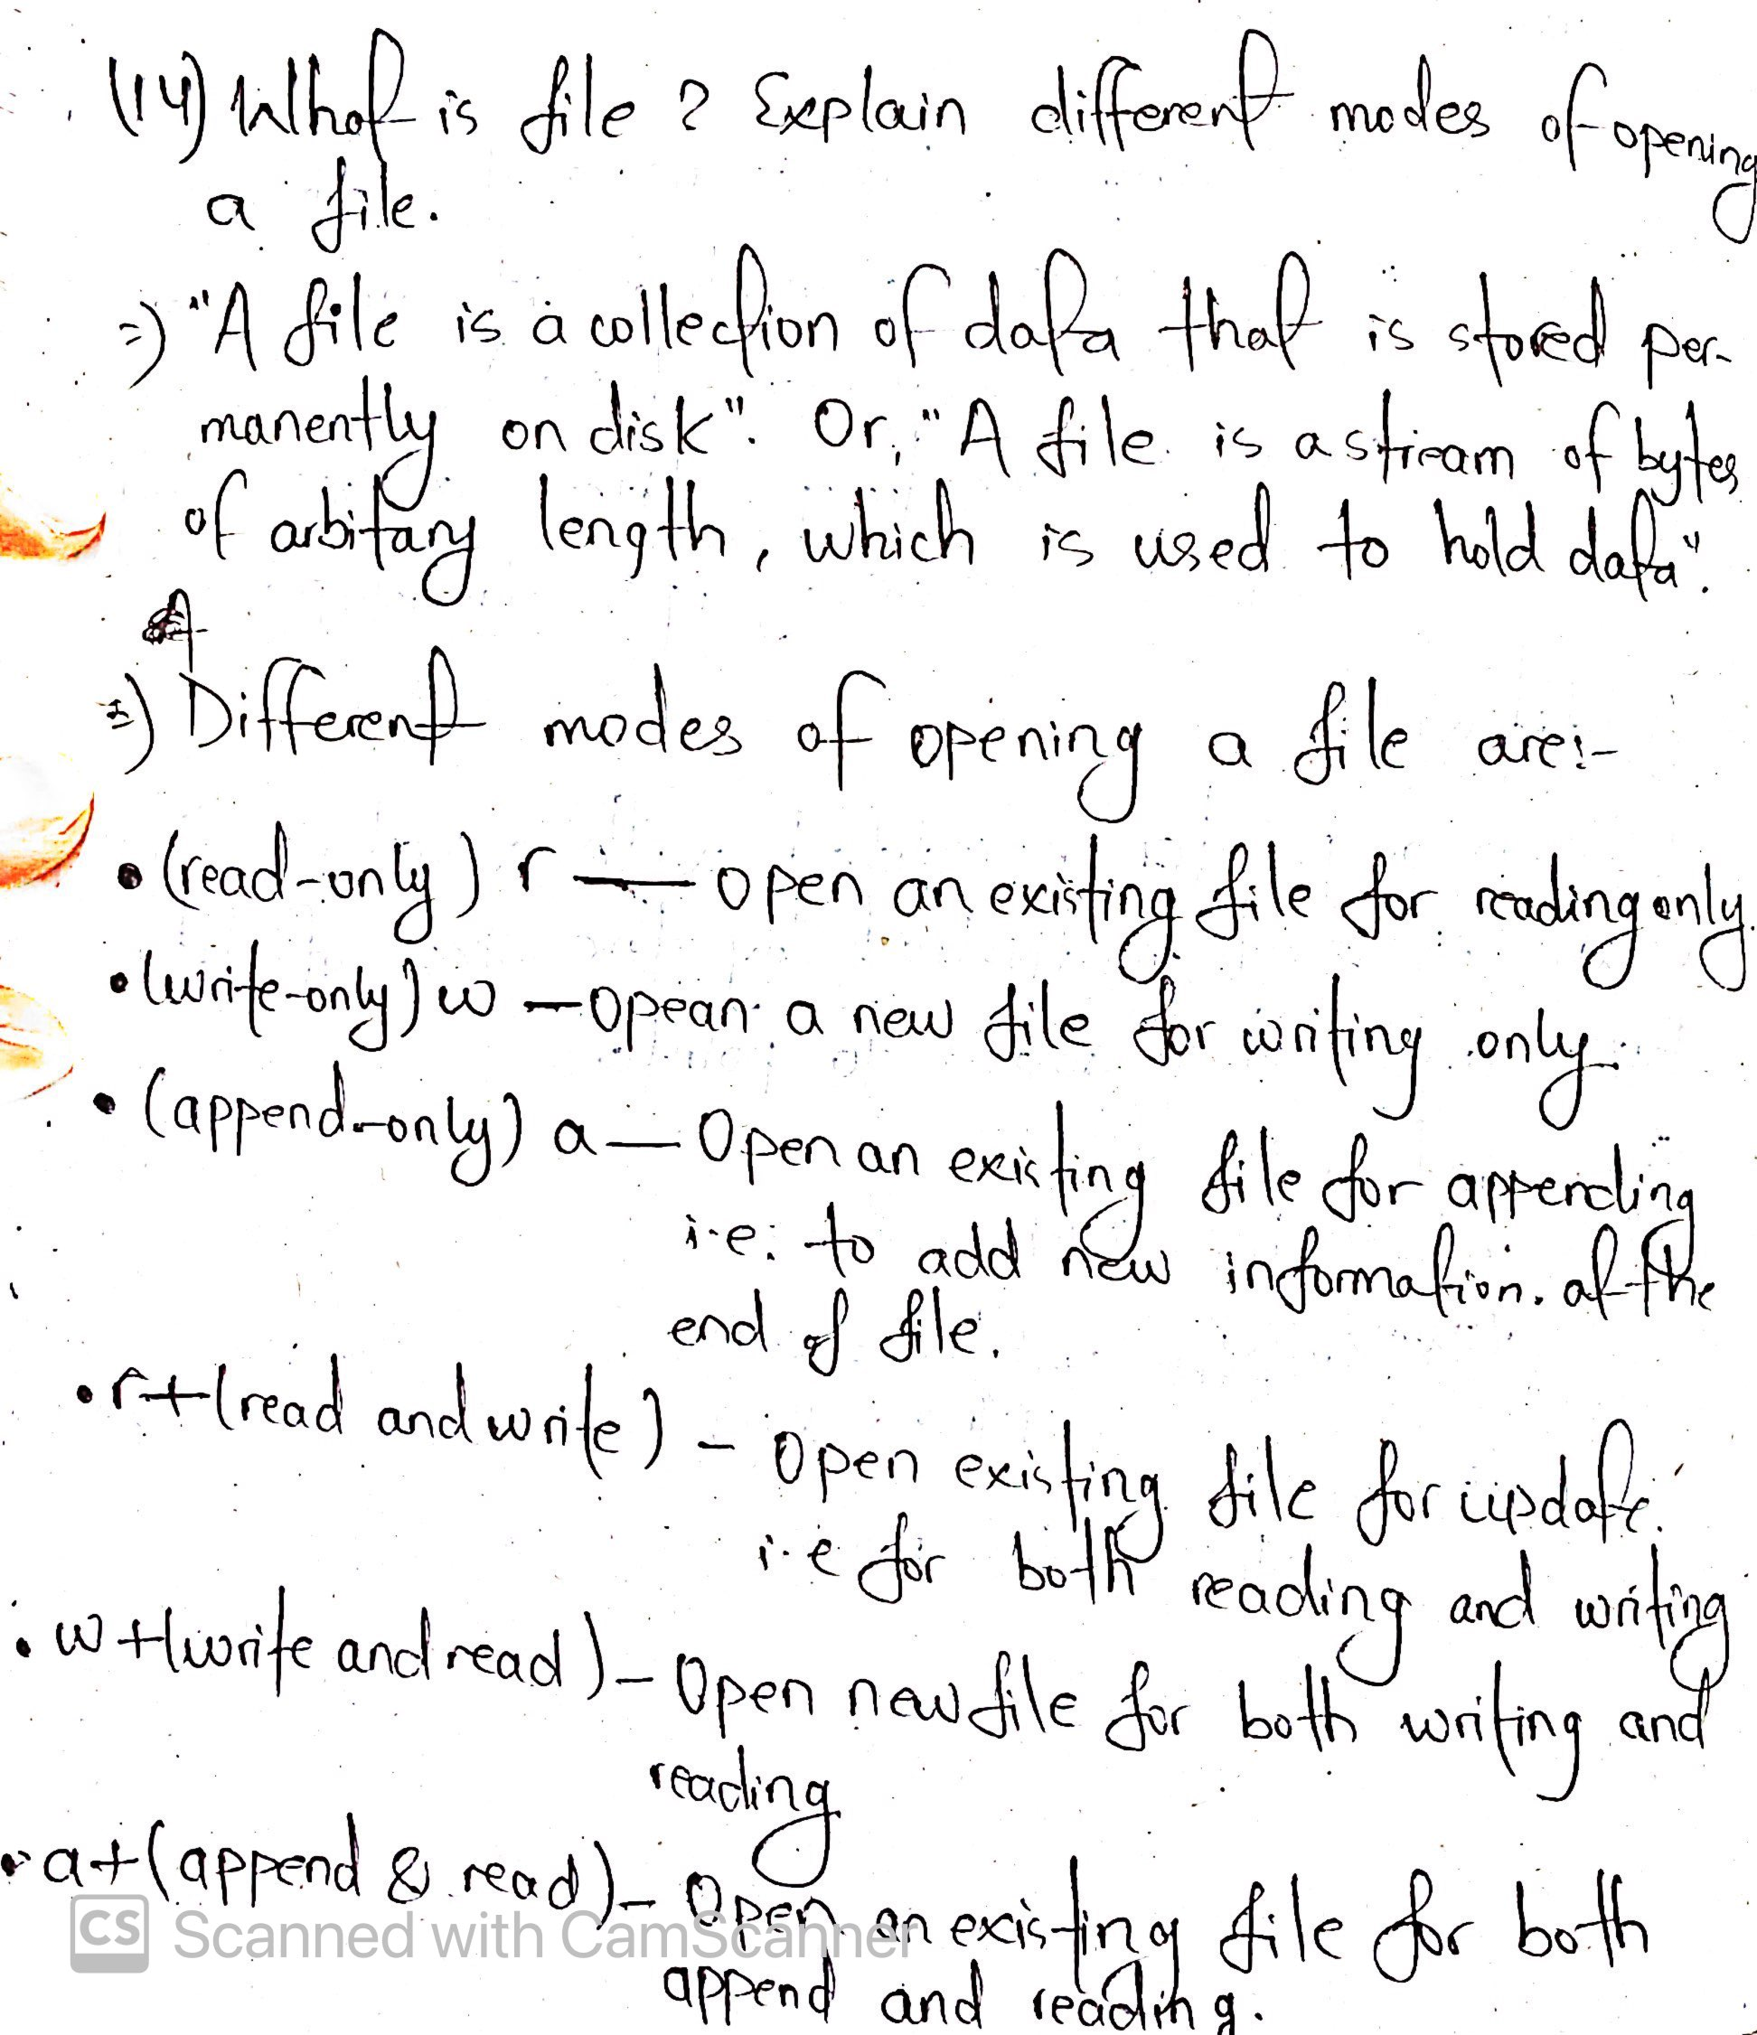

1. **Write a program to demonstrate read and write operations on a file.**

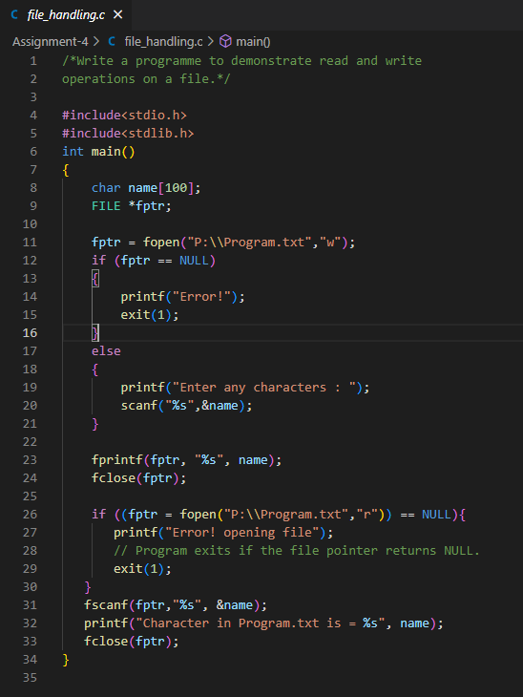

1. **Explain about fscanf(),fgets(),fprintf() and fwrite() functions with suitable examples.**

AND

18. **Explain different file handling functions with syntaxes**

**and suitable examples.**

* Different file handling functions are listed below:

|  |  |  |
| --- | --- | --- |
|  | 1. fopen() | opens new or existing file |
|  | 1. fprintf() | write data into the file |
|  | 1. fscanf() | reads data from the file |
|  | 1. fputc() | writes a character into the file |
|  | 1. fgetc() | reads a character from file |
|  | 1. fclose() | closes the file |
|  | 1. fseek() | sets the file pointer to given position |
|  | 1. fputw() | writes an integer to file |
|  | 1. fgetw() | reads an integer from file |
|  | 1. ftell() | returns current position |
|  | 1. rewind() | sets the file pointer to the beginning of the file |

* Examples of all file handling functions are as follows:

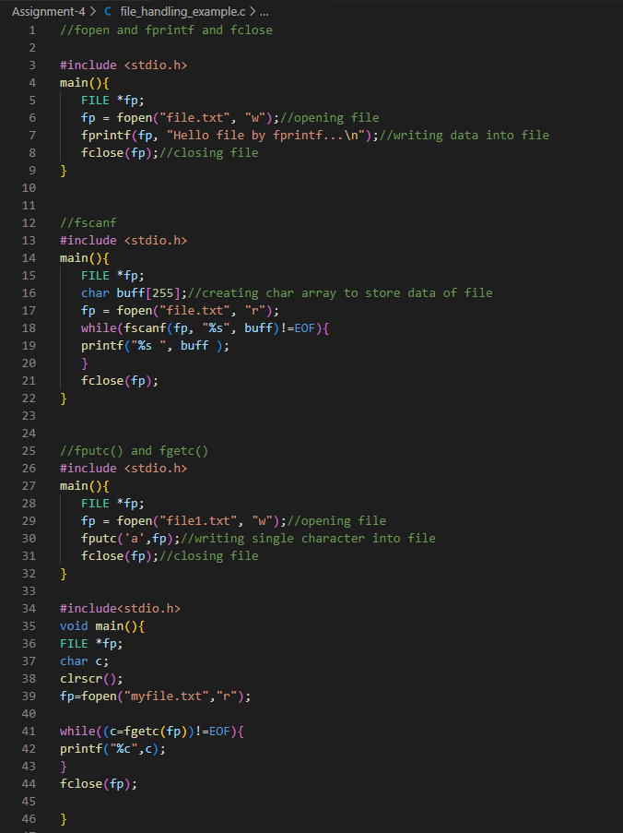

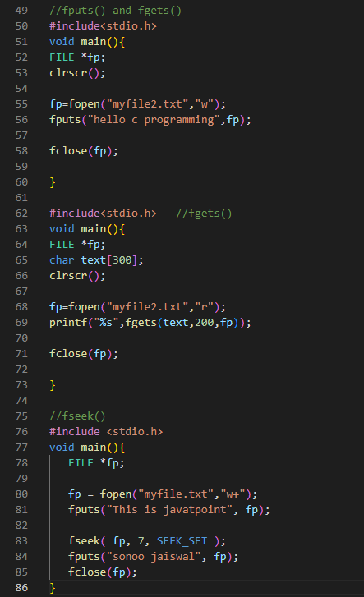

1. **Write a program to copy one file contents to another.**

* 